GROUP 2

PINEDA, WYEL

LOCSIN, MERCLEN

REYES, GIAN NATALIA

ALBA, AARON

PAMINTUAN, RENZ

VILLACERAN, HAROLD(ABSENT)

TASK #1 Create a Database

CREATE DATABASE SchoolDB;

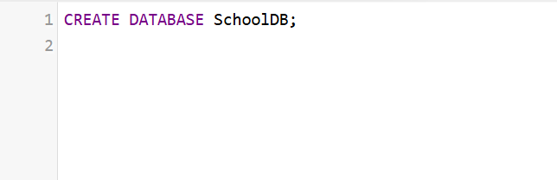

TASK #2 Use the Database

Use SchoolDB;

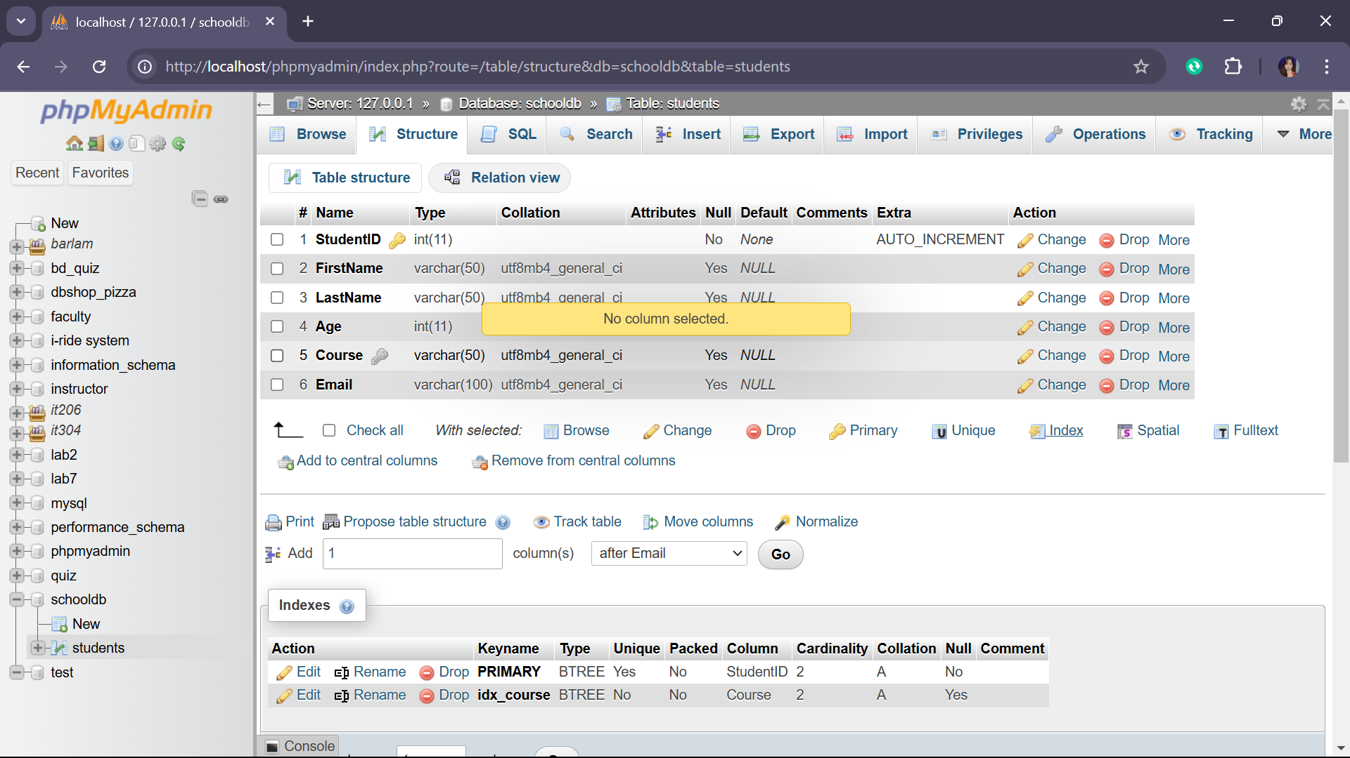

TASK #3 Create a Table

CREATE TABLE Students (

StudentID INT AUTO_INCREMENT PRIMARY KEY,

FirstName VARCHAR(50),

LastName VARCHAR(50),

Age INT,

Course VARCHAR(50)

);



TASK #4 Insert Data into the Table

Insert INTO Students (FirstName,LastName,Age,Course)

VALUES (‘John’,’Doe’,20,’BSIT’),

(‘Jane’,’Smith’,21,’BSCS’),

(‘Michael’,’Johnson’,19,’BSIS’);

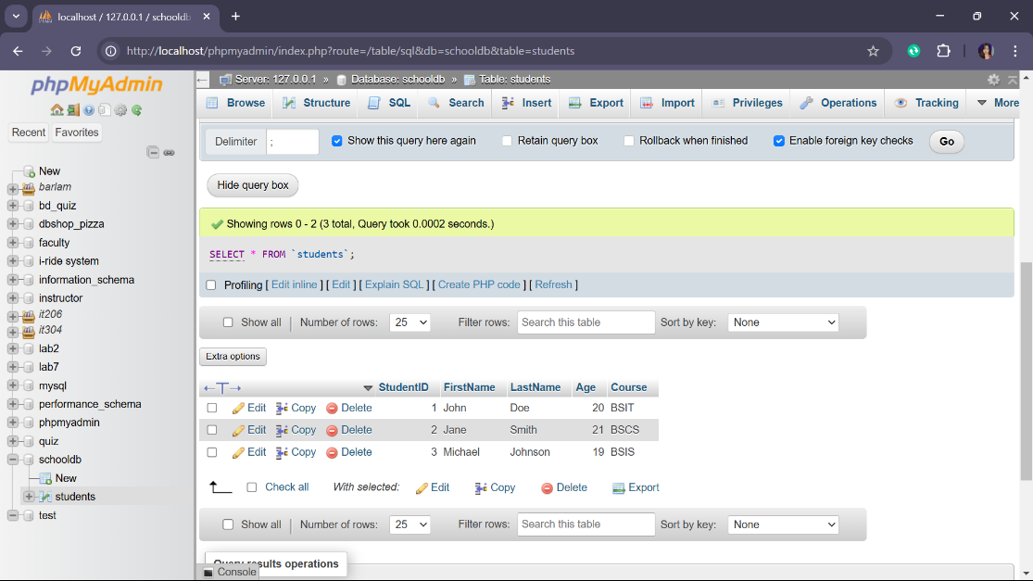

TASK #6 Update a Record

UPDATE Students

WHERE FirstName=’Jane’ AND LastName=’Smith’;

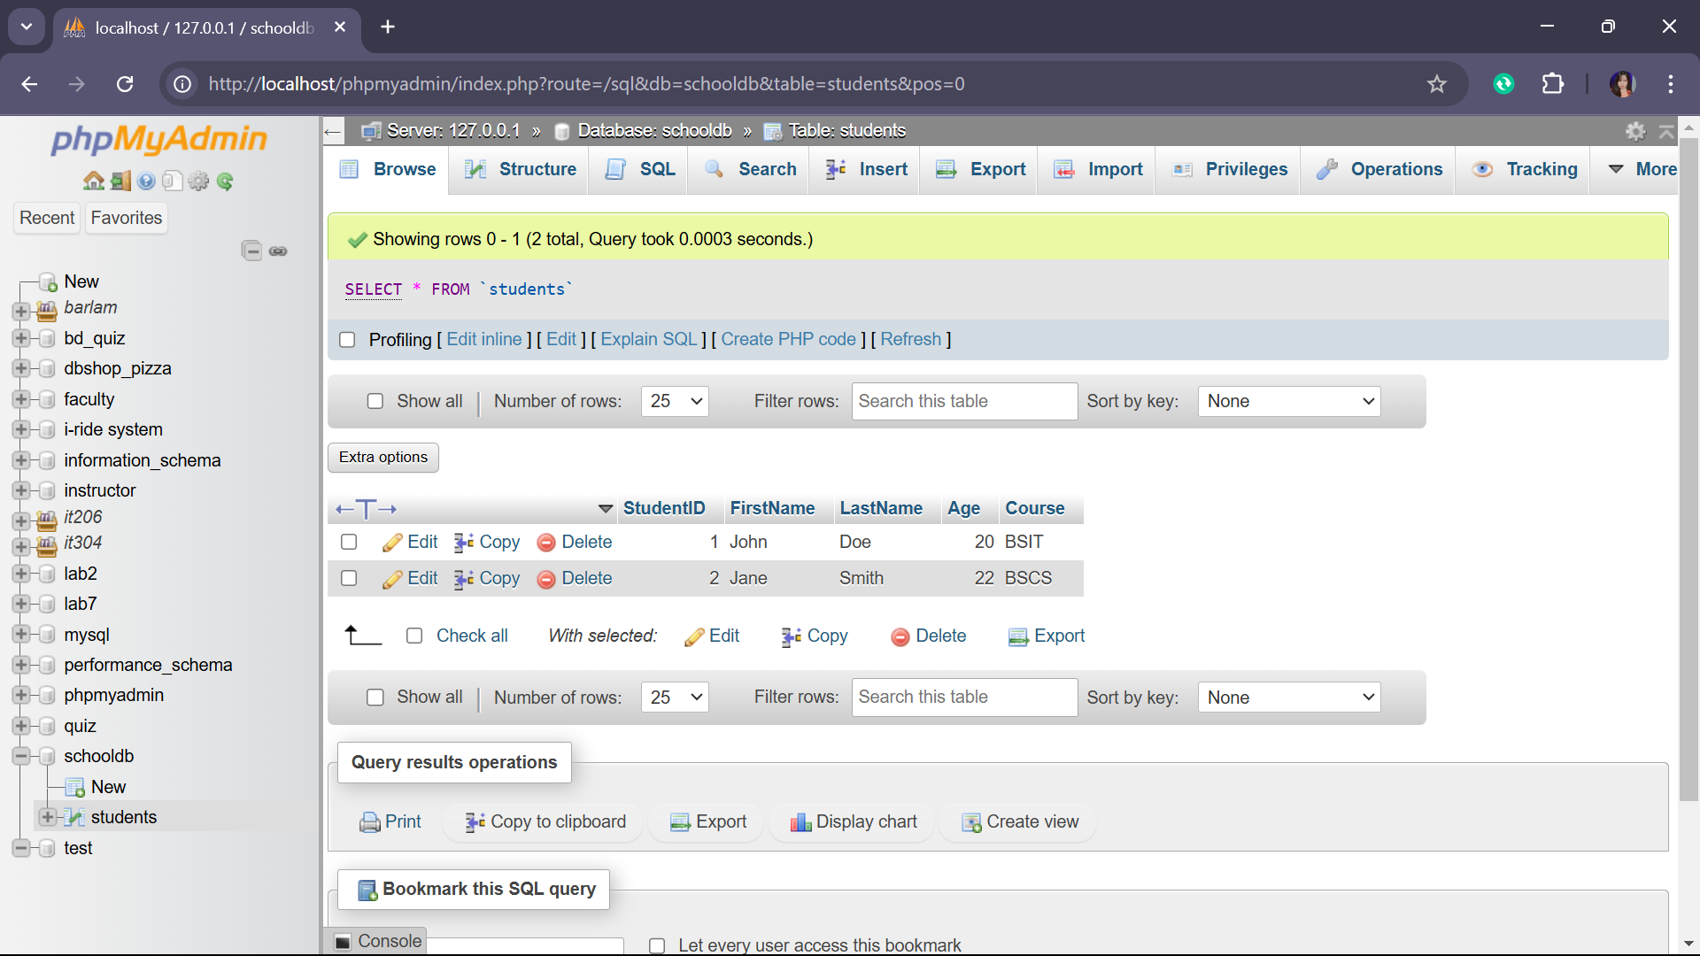

TASK #7 Delete a Record

DELETE FROM Students

WHERE FirstName=’Michael’ AND LastName=’Johnson’;

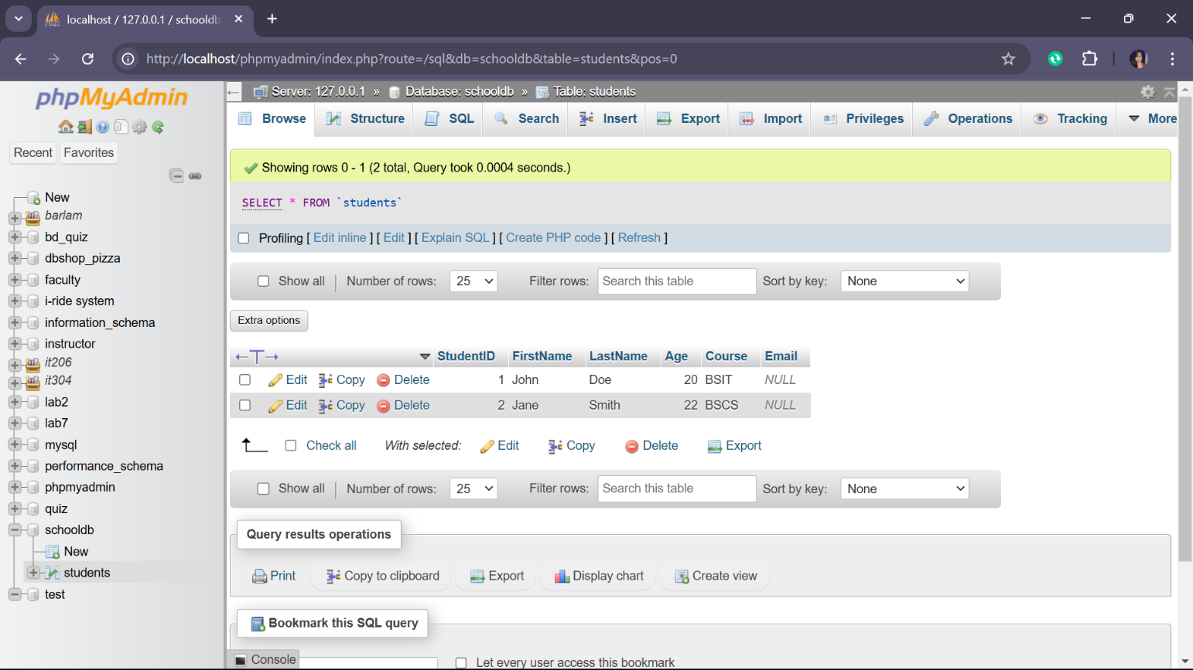

TASK #8 Alter the Table Structure

ALTER TABLE Students ADD Email VARCHAR(100);

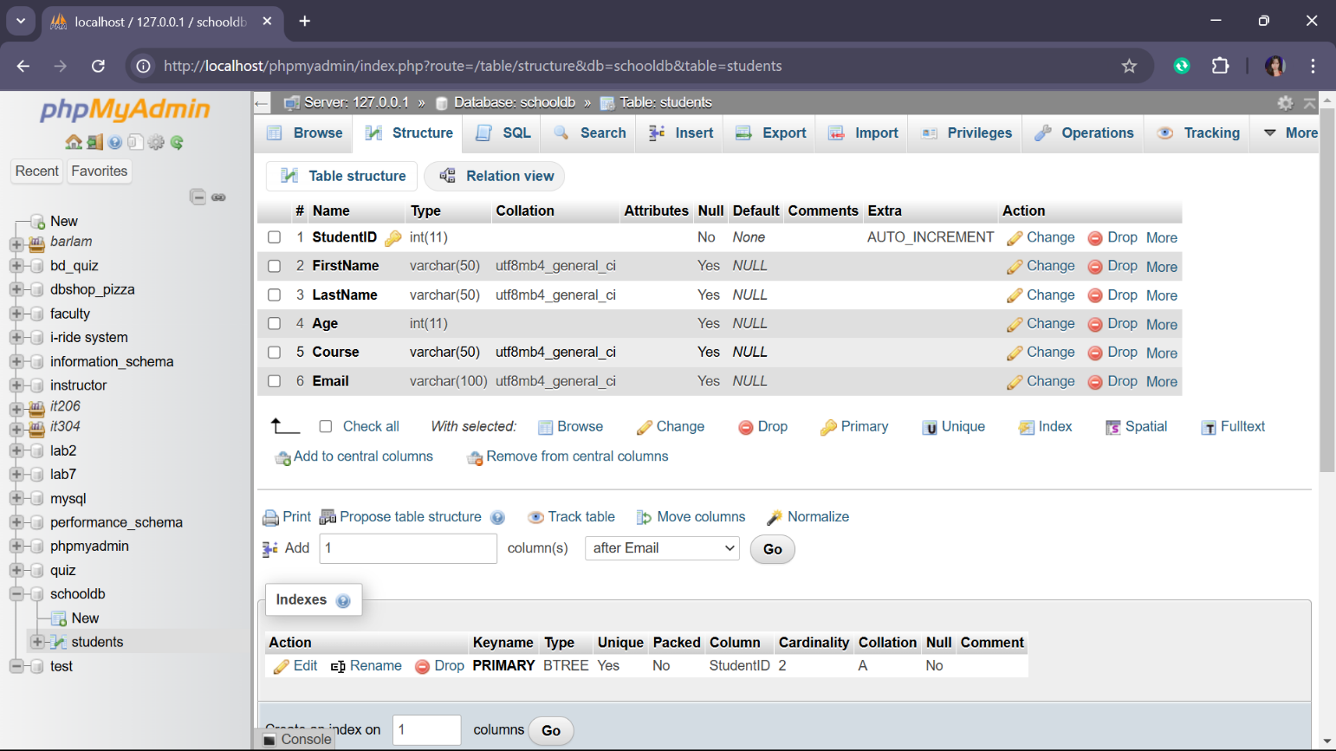

TASK #9 Create an Index

CREATE INDEX idx_course ON Students(Course);



TASK #10 Drop an Index

DROP INDEX idx_course ON Students;



TASK #11 Drop the Table

DROP TABLE Students;

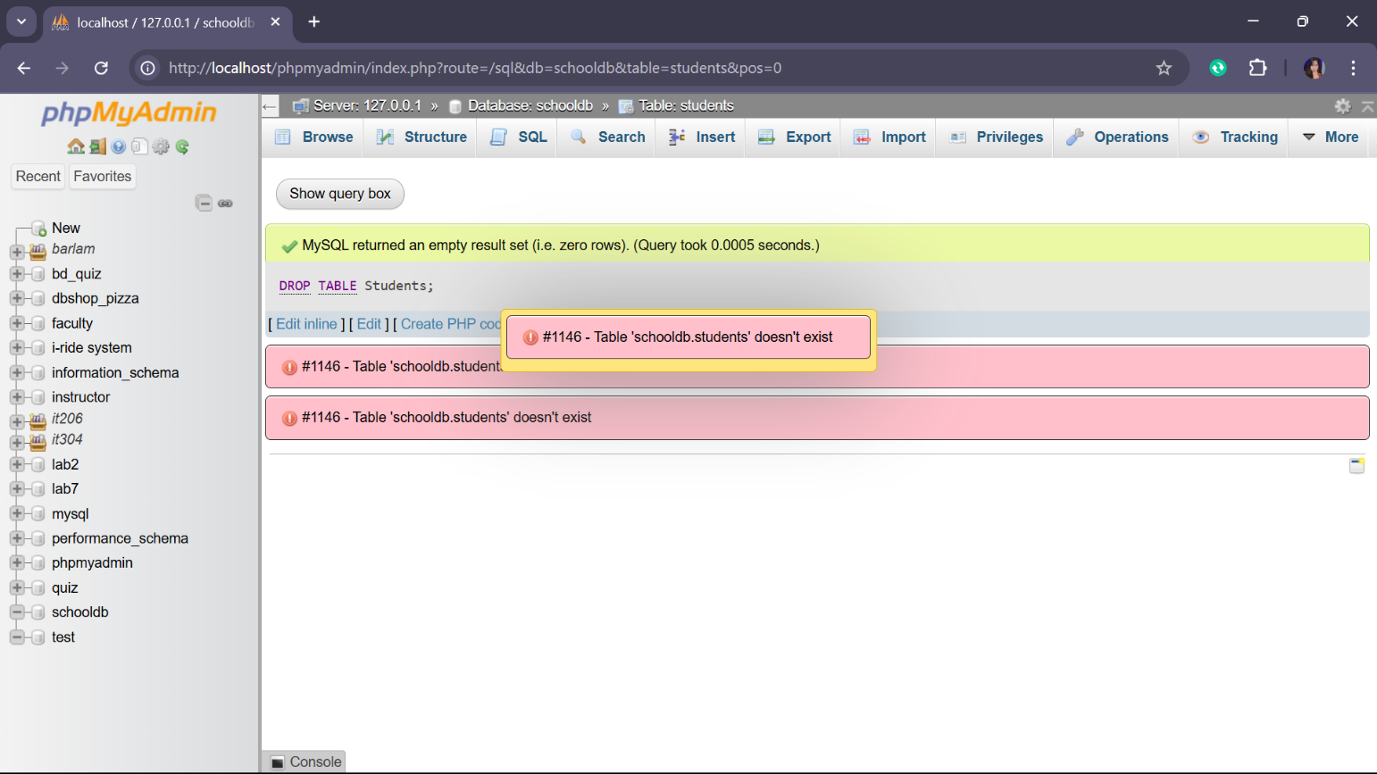

TASK #12 Drop the Database

DROP DATABASE SchoolDB;

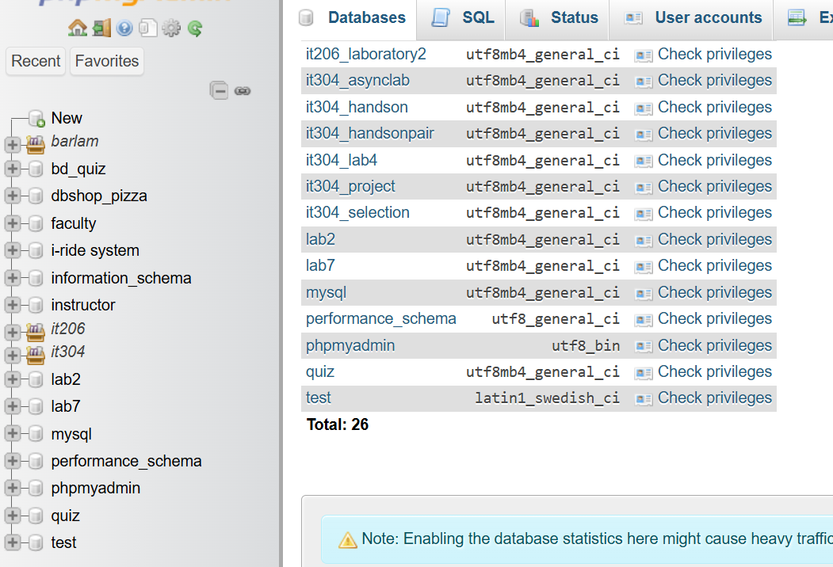

REFLECTIONS ANSWER

1. The problem and challenges in executing the SQL command as the part of forgetting to add coma and semi-colon in every process checking each command to make sure the coma and semi-colon is included.
2. These commands are crucial for businesses to manage customer data process transaction and keep information up to date. They ensure everything runs smoothly in application like banking system,online shopping and more.
3. If I will design a database for school or business I will include tables for student, teachers,courses,enrollment,grades and for business, customer, employees,product,suppliers,order,payments and inventory. These tables will help track student and teachers for school and ensure proper tracking of sales customer and inventory management for the business.